We welcome you at IMAMPC2024
The title of your contribution goes here (fontsize 14, bold)
D.G. Piekarski¹, M. Tomza², A. Kubas¹
¹Institute of Physical Chemistry, Polish Academy of Sciences, Warsaw, 01-224, Poland
2Faculty of Physics, University of Warsaw, Pasteura 5, 02-093 Warsaw, Poland
Please follow these rules to ensure the happiness of the organizers and the beauty of the book of abstract:
- write your abstract in Times New Roman 11pt
- use following fonts size:
  - title – 14 pts, bold
  - Authors – 11 pts, bold
  - Body/text – 11pts,
  - Figure caption – 11 pts
  - Paragraphs title (Acknowledgement, References) – 11pt, bold
- do not exceed 1page A4
- include figures in the text with max. 2MB size
- write the caption outside of the figure frame (see Figure 1 as an example).
- cite your references as [1] and [2]
- submit your abstract following procedure described at imampc2024.pl
The 13th International Meeting on Atomic and Molecular Physics and Chemistry, will take plance in Warsaw, Poland, from 9 to 12 July 2024. This conference aims to support young researchers and foster interdisciplinary collaborations. Invited talks will be given by researchers who completed their PhD within the past 10 years. In addition, a small number of experienced researchers will deliver keynote talks, providing a glimpse into the future of our field.
The event will bring together researchers from both theory and experimentation in the broad field of atomic and molecular physics and chemistry, opening up new research directions and opportunities for collaboration. We believe that the conference in Warsaw will create a pleasant environment for fruitful discussions and inspiration.
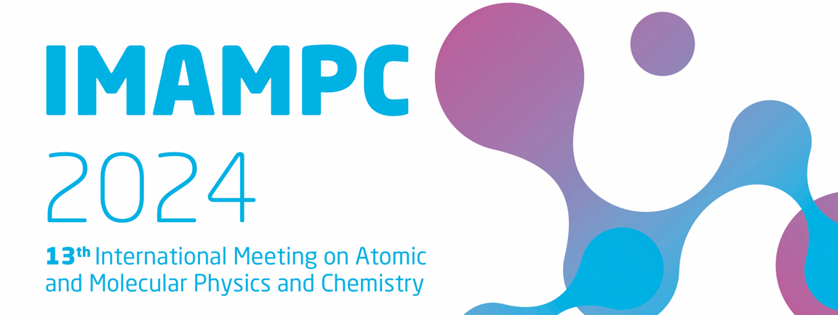
Figure 1: Times New Roman, 11 pt
Acknowledgments
Your acknowledgment text goes here.
References
- SurnameA N, and SurnameB G. Angew Chem. Int. Ed. 6 9 (2024) (font size 10)
- SurnameC F., SurnameD X., and SurnameE F. Phys. Chem. Chem. Phys. 15 1120 (2023)

E-mail: dpiekarski@ichf.edu.pl

